CS 316 Project Report

# Platform Implementation

We processed the raw data into eight relations based on the schema and uploaded them to the virtual machine. The process of constructing database in the VM is described in the README file. The file “models.py” in the source code folder defines how tables stored in the database are mapped to Python objects. Using these definitions, we then query and transform data using sqlalchemy and provide visualizations using python plotly.

Our website is implemented using HTML and Python flask. Each web page is written in a separate .html file and the web pages are linked together by flask. We finally connect our database and graphs to our website.

# Platform Design

## Framework

Our website consists of three main pages, which are the home page, the visualization page, and a page to leave comments. The home page includes a brief introduction about our website, information about the team members and links to the data source and our Github page.

The main focus of our project is on the visualization page, which includes four features: an overview of the terrorist events in terms of world map, and detailed examination of the weapon type, attack type and victim type. These visualizations enable users to explore the data in an interactive way.

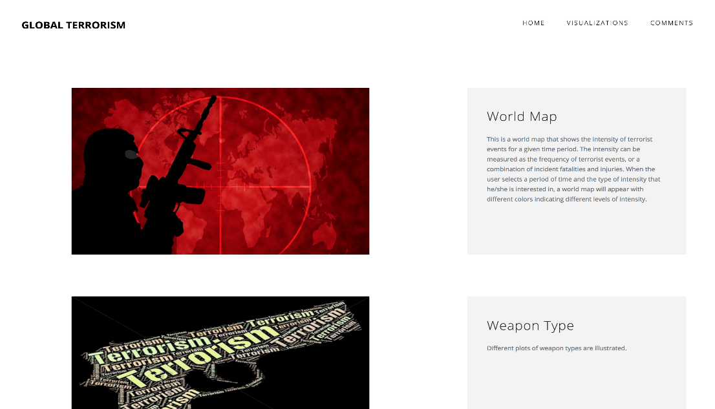

## Visualizations

### World Map

The map describes the frequency of terrorist attacks worldwide from 1970 to 2015. The color indicates the intensity of such attacks in the region. The darker the color is, the more frequent the attacks are.

In order to generate this frequency world map, we used “Location” and “Happened” table to obtain country information by joining these two tables using latitude and longitude. An outside file is introduced to match country name to unique code, which completes the implementation of the plot on Plotly.

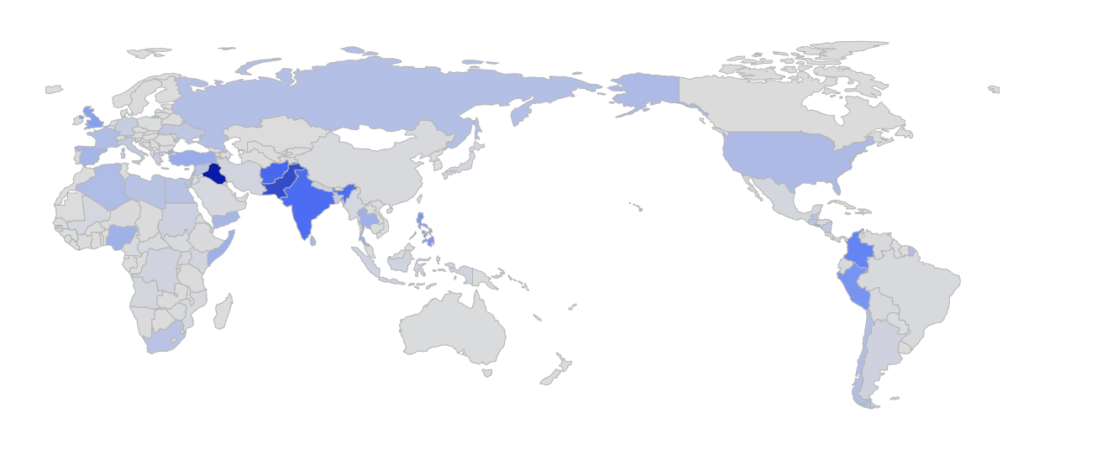

### Weapon Type

The bar chart describes the frequency distribution of weapon type used among all terrorist attacks (from 1970 to 2015). There are 12 total weapon types recorded including one unknown category.

In order to generate this bar chart, we used “Used” table to group weapon type and obtain the total count in each group using SQLalchmey. The implementation of the plot replies on Plotly.

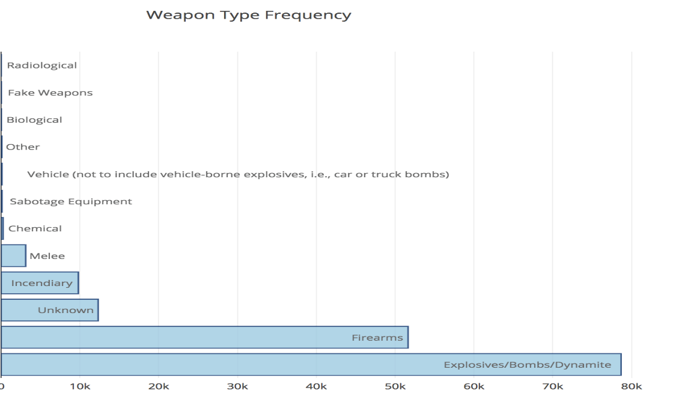

### Attack Type

The histogram below illustrates the distribution of four attack types: international (whether the attack was international), suicide (whether the incident was a suicide attack), successful (whether the attack was successful) and property (whether the incident resulted in property damage). Intuitively, most recorded incidents were successful terrorism events, and were not resulting from suicide attacks.

These four attributes were obtained by joining two tables: “Incident” and “BelongedTo” based on their common key: incident_id. The percentage distribution of each attack type were plotted rather than classifying each attack into the possible 8 categories, considering the existence of missing values.

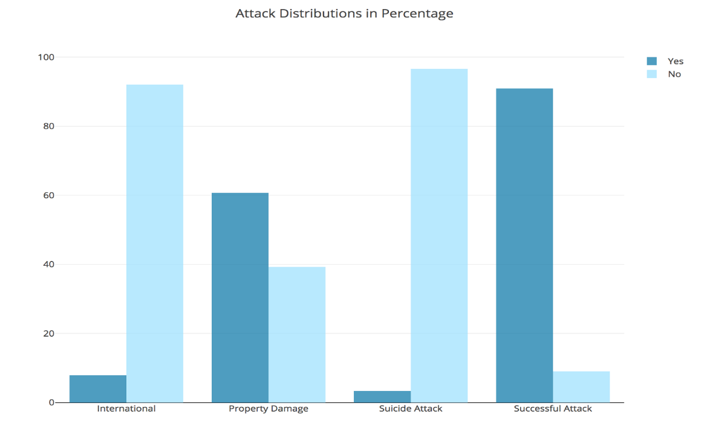

### Victim Type

This sector contains three different ways of visualizations. The first one is the number of terrorism by victim types. This graph summarizes the number of attacks of all countries by the general victim types, such as private citizens, government, transportations, etc. The second graph shows the fatality and injuries by the general victim types. Then users could select the victim type they are interested in and see more detailed subtypes within that general type. For example, private citizens and property has the largest number of fatality and injuries, we want to know more about this type. Then pie charts of various subtypes are shown, representing proportions of subtypes contributing to the overall fatality and injuries of the general type.

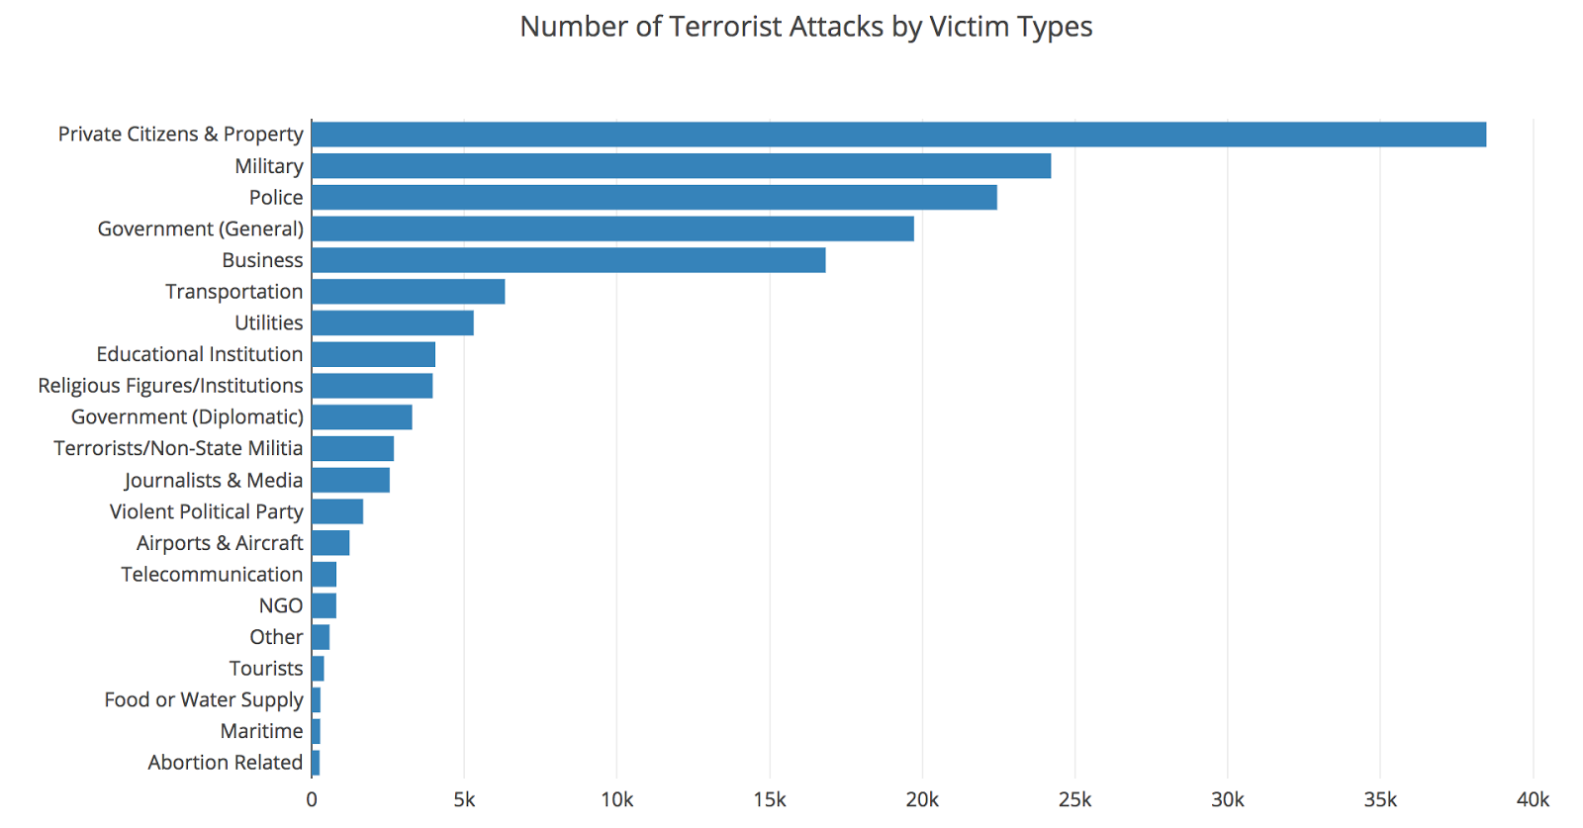

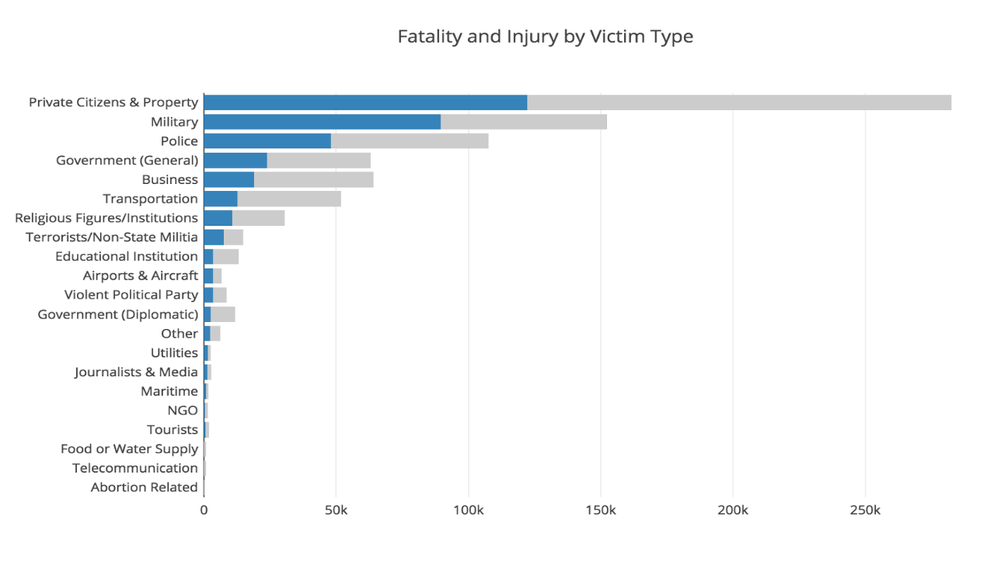

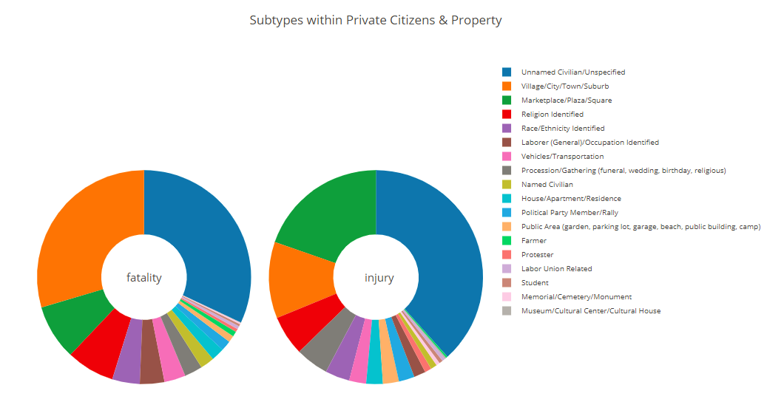

## Comments

If users are interested in expressing their thoughts about the terrorist events, they can leave a comment on our website. After filling out their personal information, they can write a message and then click on the “COMMENT” button. The website also randomly displays a few comments stored in the database.

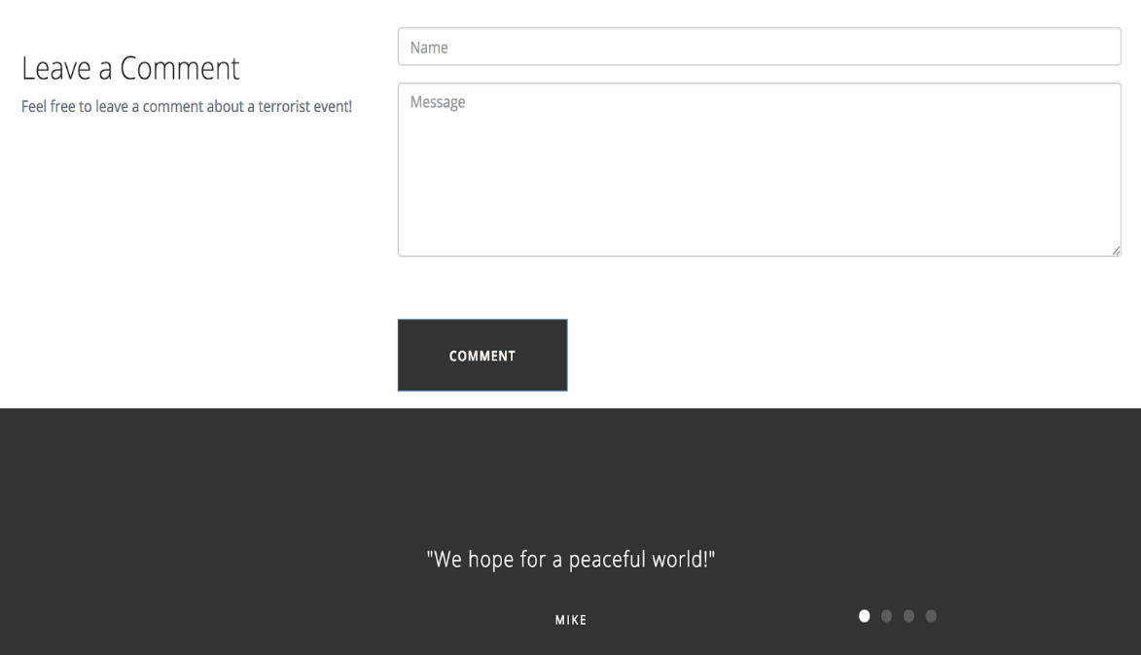

# Future Plan

We have finished building our database in virtual machine, constructing our website application, and connecting the database with the website. All the visualizations on our website right now are static plots using data queried from the database. For the next step, we plan to add drop down buttons and side bars so that users can select certain features and custom the plots. For example, under the victim sector, we will allow user to select from various victim types and then pie charts of subtypes will change based on user-select victim type.

We have not enabled the comment page to work. Our next goal is to let users leave comments, which will be added to our database automatically. We will also display randomly selected comments from past users.

In additional to perfect current functions of the website, we plan to add another data source and look into the relationship between our two data sources. We will get the news coverage data from potentially Google news API and add it to our database. We want to visualize the news coverage rate of terrorism attacks compared to the actual occurrences of terrorisms. We will also allow users to customize their plots and explore different aspects of the two data sources.